 | Brian  Thornton  Cell: (260) 267-6520  Email: Brian@Brian17.com  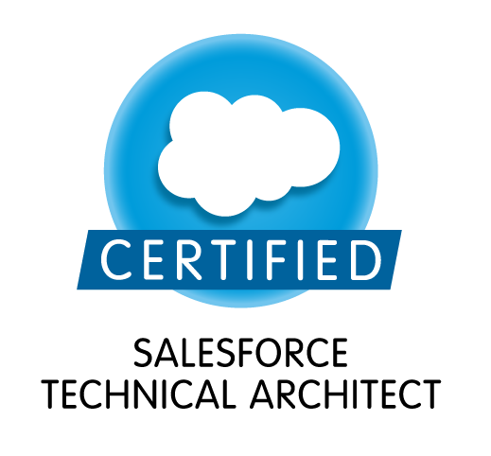 | SUMMARY  I am a seasoned hands-on certified Salesforce architect, developer and administrator, I have worked solely with advanced SalesForce APEX, VisualForce, force.com, health cloud marketing cloud and java since 2005. I’m the Coauthor and contributor to the official Salesforce Web Application Kit for Nonprofits and I have been fortunate to have presented at several Salesforce conferences. I am one of the worldwide 122 certified salesforce architects, I am an US citizen and seek full-time and part-time employment or contract.  EXPERIENCE  Salesforce, Inc  Salesforce Architect & Developer  Professional Services  San Francisco, New York and Remote  2010-CURRENT  Salesforce Architect and hands-on developer and consultant for Fortune 500 clients on behalf of Salesforce, Inc. Lead and oversee heads down development and engineering of remote and overseas development resources for 8 salesforce orgs.  Accomplishments  - Salesforce with recursive AWS IDE Instances for clients utilizing GitHub and Amazon for stability  - APEX, VisualForce, MSSQL/MySQL/Oracle and DynamoDB  - Contracted by Peachpit Press to contributed to the Salesforce Web Application Kit for Nonprofits  - Speaker at numerous Salesforce conferences  - Assisted in rollout of multimillion dollar Salesforce deployments and client architectures  - Clients/Partner include Deloitte, HP, HCL, SalesForce.com, Google, Adobe, Health Corporation of America & Simon Property Group  - Separation of HP, Inc and it’s 380,000 employees as part of the HPI/HPE and across 6 Salesforce orgs  - At OneAmerica of Indianapolis in 2014 I as the Salesforce architect built out an entire Salesforce team of 3 developers and QA/BA team of 9 for 1800 Salesforce users  - in 2013, At Simon Property Group oversaw of Indianapolis all Salesforce projects  - Mount Sinai - 350,000 patients connects using Health Cloud communities LINK  - Mattel - Salesforce Marketing Cloud for use of Journey Builder and other tools across 11 toys brands. LINK  - Northeastern University - developed Center of Excellence for 11 Salesforce Orgs for all system integration, student records and student/parent/employer engagement. LINK  - NCH Corporation - With top tier implementation partner, deployed 8 week Force.com instance for 11,000 employee with Boomi ETL  - Home Depot - Connected 80,000 professional contractor to HomeDeport through the ProReferral product converted from java microservices to full Salesforce SDLC with continuous integration.  National Association of Heavy Equipment Training Schools  Salesforce Developer/Technology Manager 2006-2010  Oversaw and developed all electronic materials with specific focus on data driven marketing.  Accomplishments  - Converted from Zend PHP framework to SalesForce billing/marketing System  - Moved all servers from in-house server to cloud based AWS with Salesforce orgs  - Architected and Developed:  - Full Content Management  - Student Management System  - Lead Tracking with physical newspapers  - DVD distribution and return mail tracking system  CERTIFICATIONS: (See next page for print out of certifications)  Salesforce  Salesforce Certified Administrator - September 1, 2008  Salesforce Certified Force.com Developer- March 27, 2009  Salesforce Certified Advanced Administrator- March 27, 2009  Salesforce Certified Sales Cloud Consultant - July 11, 2011  Salesforce Certified Service Cloud Consultant - July 12, 2011  Salesforce Certified Technical Architect - August 1, 2012  Salesforce Certified Platform Developer I - September 11, 2015  Salesforce Certified Platform Developer II - September 11, 2015  Salesforce Certified Marketing Cloud Email Specialist - September 13, 2016  Cisco  Cisco CCNA Certification - 2002 (expired)  Microsoft  MCSE + TCPIP - 2004 (expired)  Microsoft Certified Database Administrator  University of Nevada Las Vegas/Indiana Purdue - Fort Wayne  Computer Science and Consumer Marketing — 1998-2012 (continuing)  President of the PRSSA and cofounder of the SalesForce User Group.  SKILLS  - Comprehensive Salesforce Experience  - Iterative Development  REFERENCES  Available upon request.

